**Customer Sales & Purchase Behaviour Analysis**

**Name: Gandu Beaula**

**Course: Data Analytics**

**BatchNo: BN001**

**City: Hyderabad.**

**Domain:** Retail

**Focused On:** Hasbro, Hamleys, Mattel, and Lego (Considered as Top players in Toy retail Industry)

**Companies Overview:**

Hasbro, Hamleys, Mattel, and Lego are globally recognized leaders in the toy and entertainment industry, each with a unique legacy and market presence. **Hasbro**, based in the U.S., is known for iconic brands like Transformers, Monopoly, and Nerf, blending physical toys with digital experiences. **Hamleys**, headquartered in the UK, is one of the oldest and most prestigious toy retailers in the world, offering a premium in-store experience that emphasizes interactive play and tradition. **Mattel**, another U.S.-based powerhouse, is the creator of timeless brands such as Barbie, Hot Wheels, and Fisher-Price, focusing on innovation and educational play. **Lego**, originating from Denmark, revolutionized creative play with its interlocking brick system, fostering imagination and problem-solving skills through both physical sets and digital platforms. Together, these brands shape the global toy industry, combining heritage with innovation to captivate generations of customers.

**Objective:**

To analyze sales performance and customer behavior patterns across four leading toy retailers, identify market trends, and uncover actionable insights to improve revenue, customer loyalty, and engagement.

**Business Questions:**

* How many unique customers were involved in the sales data?
* What is the total quantity of products sold
* What is the average price of products sold
* How do sales vary across the days of the month? Are there specific dates showing peaks or dips?
* Which product category contributes the most to total sales?
* How does each brand perform across different product categories?
* What is the distribution of sales across Online vs. Offline channels?
* What is customer segmentation across age group ?
* Which channel is capturing the highest rating ?
* Find customer purchase pattern across age group are there any repeat purchases ?
* What is the feedback split across customers ?
* What is the retention rate of customers ?
* What is the average basket size ?
* Which loyalty status and age group combination provides the highest Customer Lifetime Value (CLV), and how can we focus efforts on growing that segment?

**📊 1. Sales Dashboard Overview**

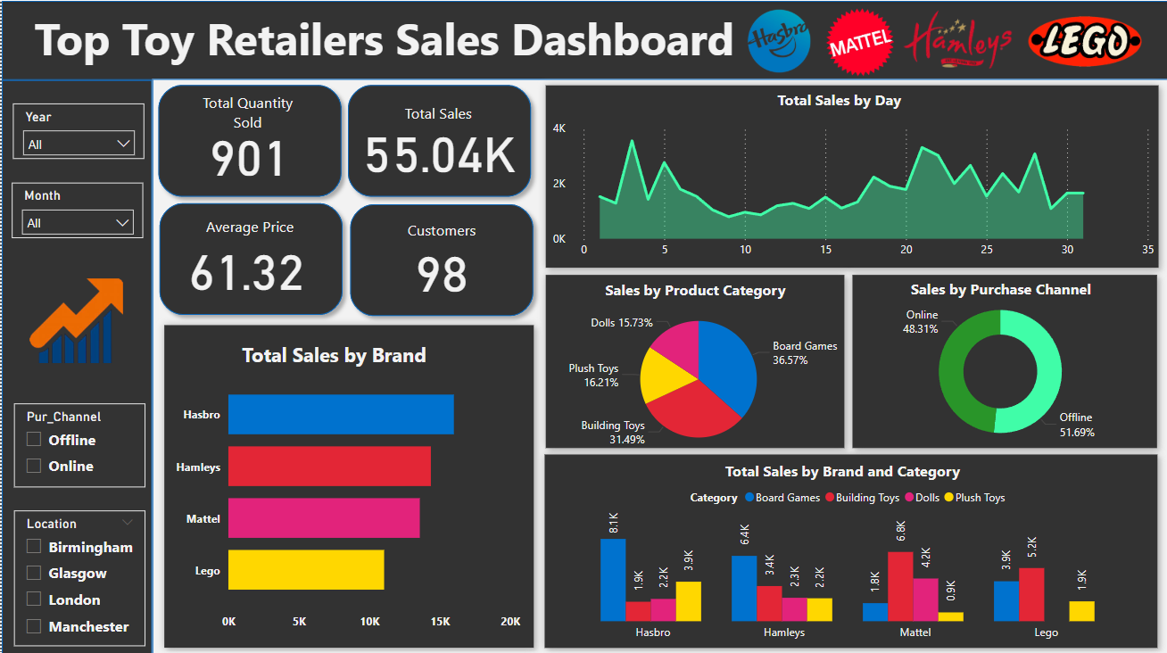

**Purpose:**  
To track key performance metrics such as total sales, quantity sold, and brand-wise performance.

**Key Highlights:**

* **Total Sales:** $55.04K
* **Total Quantity Sold:** 901
* **Average Price:** $61.32
* **Customers:** 98
* **Top Performing Brand:** Hasbro
* **Best-selling Category:** Board Games (36.57%)
* **Purchase Channel Split:**
  + Offline: 51.69%
  + Online: 48.31%

**Visuals Included:**

* KPI Cards (Sales, Quantity, Customers)
* Sales Trend by Day
* Sales by Brand & Product Category
* Sales by Purchase Channel
* Sales by Brand and Category (stacked column chart)

**📈 2. Customer Behaviour Analysis Dashboard**

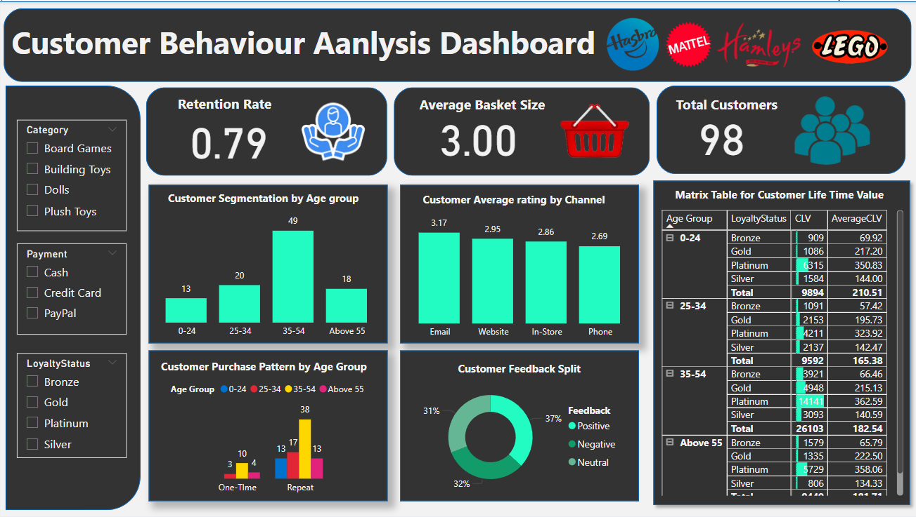

**Purpose:**  
To understand customer demographics, buying patterns, and overall satisfaction.

**Key Highlights:**

* **Retention Rate:** 0.79
* **Average Basket Size:** 3 items
* **Top Age Group:** 35–54 (49 customers)
* **Highest Rated Channel:** Email (3.17 avg. rating)
* **Customer Feedback:**
  + Positive: 37%
  + Neutral: 32%
  + Negative: 31%

**Visuals Included:**

* Customer Age Segmentation
* Average Rating by Channel
* Feedback Split Pie Chart
* Purchase Pattern by Age Group
* Lifetime Value Matrix by Age & Loyalty Status

**📌 Filters Available:**

* Year, Month, Channel, Location (Sales Dashboard)
* Category, Payment Method, Loyalty Status (Customer Dashboard)

**✅ Insights & Recommendations:**

* Focus more on **offline sales optimization** as it holds a slight majority.
* Strengthen engagement with the **35–54 age group**, which shows the highest customer count and CLV.
* Encourage **repeat purchases** through loyalty programs for younger age groups.
* Address **negative feedback** on the phone and in-store channels.